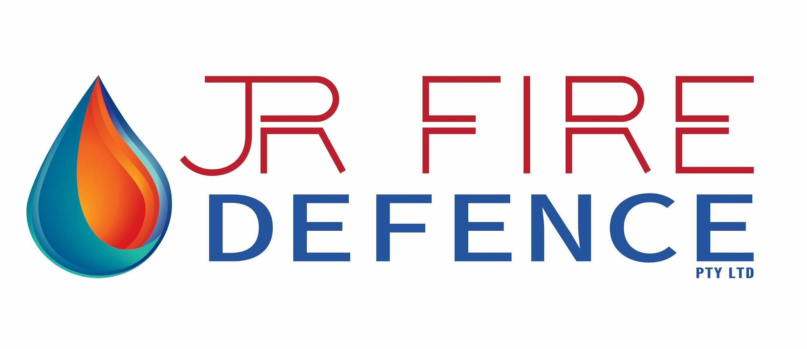

Sunday, 26th October 2025
RESPONSE TO REQUEST FOR PROPOSED FIRE SERVICES
ABRONIA APARTMENTS STAGE 1 – 41 Skyview Ave, Rochedale.

SYSTEMS OFFERED
➢ Combined sprinkler and hydrant system including hose reels.
➢ Automatic Fire Detection and Emergency warning system. (FDCIE/EWCIE/FFCP)
➢ Interface with buildings combined hydrant/sprinkler system (AS2118)
➢ Interface with Mechanical plant basements.
BASIS OF PROPOSAL – DESIGN & CONSTRUCT.

− Relevant Standards: NCC 2022 V1, AS3000 AS1668, AS1670.1-2018, AS 2118 Part 6 and AS 1221
− Fire Drawings: 2024299; FA000-2, fa100-1, FA101-2, FA102-2, FA103-1, FA200-2, FA201-2, FA202-2, FA203-2, FA204-2, FA205-1, FA300-2, F00-01-10, F00-02-10, F00-31-10, F00-70-10 to F00-70-15, F15-10-10 to F15-10-13 and F15-10-10 to F15-10-15.
− FER Rev 001 Dated 24-10-25
− Design and Construct Fire Alarm Services Specification – Issue 1 - March 04th 2025

Proposal Price:
Fire Sprinklers: | $820,600:00
Fire Alarm Price: | $162,400.00
Total: | $983,000:00
GST: | $98,300:00
Total Price: Including GST | $1,081,300:00
Our Fixed Price will remain valid for 60 days from the date of submission.

SCOPE OF WORKS - WET FIRE - BUILDING A & B

▪ Supply and install a 150mm water meter and back flow prevention assembly.
▪ Supply and install dual fire & hydrant pumps and pipework including the booster assemblies and brigade tanks suction.
▪ Supply and install hydrants and hose reels throughout including hydrant test drain.
▪ Supply and install sprinkler control valves to all levels.
▪ Supply and install exposed sprinklers to car park levels.
▪ Supply and install concealed and semi recessed sprinklers to all residential areas including protecting bin chutes every 2nd level and sprinklers in the bottom of the lift shaft.
▪ Supply and install 150mm underground mains from the booster cabinet and between building A & B.
▪ Supply and install all plastic penetrations for risers and balcony heads.
▪ Provide fire rating off all required penetrations including certification,
▪ Preparation and submission of detailed workshop drawings and as-builds.
▪ Block plans for the booster assembly.
▪ Operations & maintenance manuals.
▪ Commissioning and testing.
▪ 12 months maintenance.
▪ 12 Months warranty.

WET FIRE - EXCLUSIONS
▪ We have made no allowance for two 50KL concrete tanks.
▪ We have made no allowance for sealing off the concrete tanks.
▪ We have made no allowance for any holes required for the concrete tanks.
▪ We have made no allowance for the sprinkler pump room.
▪ We have made no allowances for concrete plinths for the pumps.
▪ We have made no allowance for the concrete slab for the booster cabinet.
▪ We have made no allowance for the disposal of any leftover materials from the trenches after backfilling.

SCOPE OF WORKS - DRY FIRE - BUILDING A & B

▪ Main FDCIE in Building B and Sub FDCIE in Building A.
▪ Allowance for capacity to link to future stages in the first and subsequent stages.
▪ Fire Control Centre in each building - Networked addressable fire detection control and indicator
panel with combined emergency warning system. Including all fire fan controls. FDCIE/EWCIE/FFCP
▪ Interface with building combined hydrant/sprinkler system, fire pumps, monitoring valves, control
valves, DBA, booster cabinet IV and pressure switch for a complete system.
▪ Interface with basement mechanical plant, smoke exhaust fans, supply air fans and jet fans. Including
duct probes, onboard jet fan smoke detectors and circulation space smoke detectors in accordance
with the FEB & AS1670 & AS1668.
▪ Allowance for FDCIE to initiate a signal to the respective mechanical services switchboards for fire
mode shutdown of air handling systems. Allowance to liaise closely with the mechanical services
contractor to ensure all control functions operate in accordance with the requirements of AS 1668,
AS 2118, AS 1670 and the specification.
▪ Addressable smoke detectors in all public corridors and internal public spaces in accordance with
NCC and AS1670.1.
▪ Allowance for MASD for protection of the top of lift shafts as per drawings.
▪ Evacuation speakers in all bedrooms and horn speakers throughout basement in accordance with
NCC and AS1670.1.
▪ Fire Alarm red strobe to building entry and booster location to indicate when building is in alarm.
▪ Fire signal to fire doors, auto doors and gates to auto unlock in case of fire were used as a path of
escape.
▪ Fire signal to Electric Vehicle charging power shutdown control circuit in the fire control room
▪ Fire signal to gas shutoff solenoid on activation of fire alarm.

GENERAL
▪ Fire cable, conduit in slabs, fixings and sundries.
▪ Allowance to fire rate all required fire system penetrations and certification.
▪ Provision of a fire alarm signal to the security/access control system for release of specified doors &
electric locks.
▪ Commissioning of fire system and interface performance testing with other associated trades.
▪ Shop and as-Installed drawings.
▪ Commissioning documentation (Form 12) baseline data and installers statements.
▪ QFES inspection
▪ Provision of alarm signalling equipment (ASE) in the FIP. Include dual 4G connection facility.
▪ FDCIE block diagrams
▪ Operations & Maintenance Manuals
▪ 12 months warranty
▪ 12 Months maintenance compliant with AS1851 for the DLP

CLARIFICATIONS/EXCLUSIONS
1. All work will be carried out during normal working hours 6:30am to 3:30pm Monday to Saturday
excluding public and award prescribed holidays or as required to maintain sequencing the works
program.
2. We have made no allowances in this quote for installing electronic security systems door holding
devices, tactical evacuation plans, fire blanket, extinguishers, sliding fire
doors interface, Magnetic door holders and MCPs. If required, we can provide additional quotations on request.
3. No allowance for brigade connection and ASE. Local alarm only
4. No allowance for FFCP due to no mechanical carpark ventilation required.

Regards,
J R Fire Defence
86 Kessels Boulevard
Greenbank QLD 4124
+61456952776
ron@jrfiredefence.com
ABN 662965442

